Forthcoming Rotas
25 January | 10.30am Revd Martin Ramsden
Steward | Iain Baird
Door Steward | Liz Litherland and Sheila Hargreaves
Musician | Sharon Wright
Reader | Michael Salmon
Property | Chris Frank
Fire Steward | Nigel Harris
1 February | 9am Revd Martin Ramsden - Holy Communion  10.30am Revd Sarah Ramsden - All Age HC
Steward | Ros Matthews
Door Steward | Dyala Moon and Elizabeth Prime
Musician | Nigel Harris
Reader | Eleanor Mackirdy
Property | David Peckett
Fire Steward | Dyala Moon

FIRE PRECAUTIONS
Please will all members of the ‘fire watch’ team meet before the service to delegate each person’s area of responsibility in the building. Also - a reminder that all internal doors should be closed when leaving the building. Many thanks. Paul Toplis

ROOM BOOKINGS
Email: bookings@yarmmethodistchurch.org.uk David Peckett 07837 567618

NOTICES . should be sent to June at: notices.yarmmethodist@yahoo.com or 07801549931 by 6pm on Thursday.

Welcome to Worship at

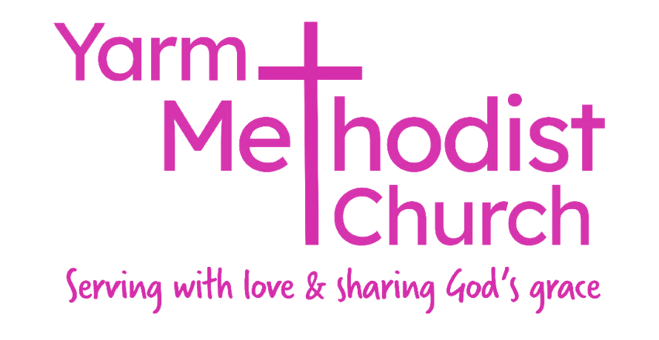
Sunday
18 January
2026

Today marks the beginning of the
Week of Prayer for Christian Unity

Preacher  Steward  Door StewardMusician  Reader  Property  Fire Steward | Revd Martin Ramsden -  Holy Communion  Victoria Harris  Dyala Moon and Rita Perry  Nigel Harris  Sheena Maberly  Paul Toplis  Ian Fyfe

Please join us for a cup of tea or coffee in the Hall after the service.

Minister Revd Dr Martin Ramsden
07483863502 martin.ramsden@icloud.com

LENT 2026
We are considering running a short course during Lent and it would be helpful to know if there is interest in a time of fellowship and informal study/discussion each week in the lead-up to Easter. Please indicate your interest on the sign-up sheet in church this week and next, and we will let you know if the Lent Course is going ahead and any details.

Church Council Meeting
The next Yarm Methodist Church Council meeting will be held on Wednesday 4th February 2026 at 7.30pm in the New Room.

OCTAGO 10 - 12noon Thursday - 22 January

REVD VINCENT is on Sabbatical leave until the end of March. Please pray for him as he uses this gift of time from the Methodist Church.


Riding Lights Theatre

Company
is one of the UK’s most productive and long-established independent theatre companies. Founded in York in 1977, partly through the initiative of a city-centre church, the company continues to take innovative, accessible theatre into all kinds of communities far and wide.
Our aim is to create unforgettable, entertaining theatre in response to current issues and the hopes and fears of the world we share. While the company’s roots are in a Christian ethos, our work is open to everyone, using faith as a springboard to explore all aspects of life.

URGENT APPEAL

COMMUNITY LARDER AT ST. ANDREWS CHURCH IN HARDWICK
An unfortunate incident at St Andrews Church has resulted in smoke damage to parts of the building. Fortunately, there were no injuries or structural damage, but insurers have appointed
specialist cleaners, a lengthy process, affecting both church and the Community Larder. We offer our prayers to all affected at St
Andrews Methodist Church as they deal with the distress and difficulties this is causing.
A major problem for the Food Larder is that all the goods are smoke damaged and have been condemned by the insurers. All food, toiletries and clothing will be destroyed. All these items have been donated, or purchased specifically with cash given by supporters, and in the course of time, insurance will hopefully cover the estimated costs. In the meantime, this vital
service to the local community is unable to re-open until cleaning is complete and they have been able to re-stock!
It would be wonderful if a concerted effort could be made in the next two/three weeks to collect as many items as possible to help re-stock and reopen at the earliest date.

ITEMS MOST NEEDED ARE
Tinned items of every kind - all vegetables, beans, spaghetti, soups, meat, tuna etc.
Tinned/packet custard, rice pudding etc.
Breakfast cereals of all kinds, biscuits Tea bags, coffee, carton UHT milk, fruit cordials etc.
Pasta, rice, pasta sauces, Pot noodles, hot dogs, quick snacks etc.
Toiletries, shower gel, shampoo, soap, spray deodorant, toothpaste, toothbrush Clothes laundry pods
If any churches are able to make a collection of any of these items, please check with Mrs Gill Carr at St Andrews Church for the best
time to deliver which may not be possible while cleaning operations continue.
CASH DONATIONS ARE NEEDED TOO.
This Appeal is supported by the Circuit Leadership Team.

